**HTML Template Directives**

A directive is a special attribute that adds dynamic behaviour to an HTML template.

**Where you can use this?**

You can use certain directives on a root <template> tag, a nested <template> tag, or an HTML element such as a <p> tag.

There are two types of directive

1. **Directives for Root Templates**
2. **Directives for Nested Templates**
3. **Directives for HTML Elements**

**Directives for Root Templates**

1. **lwc:preserve-comments**

Preserves HTML comments so that they are rendered in the DOM.

*<*template lwc:preserve-comments*>*

*<!-- This will also added to DOM -->*

*<*lightning-card*>*

*<*h1*>*

            Directive

*</*h1*>*

*<!-- Commnent at the end-->*

*</*lightning-card*>*

*</*template*>*

Output at DOM:

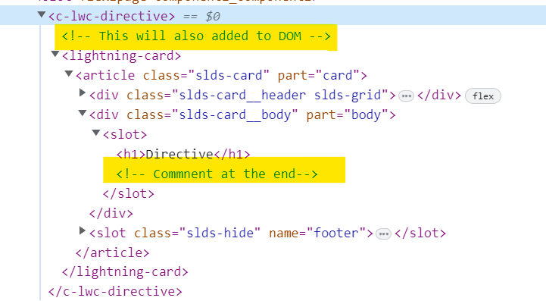

1. **lwc:render-mode='light'**

Renders a component using light DOM (Beta), which enables third-party tools to traverse the DOM using standard browser query APIs such as querySelector.

*<*template lwc:render-mode='light'*>*

*<*lightning-card*>*

*<*h1*>*

            Directive

*</*h1*>*

*</*lightning-card*>*

*</*template*>*

**Directives for Nested Templates**

A component's template can include nested <template> tags with certain directives. These nested tags support only the following directives.

1. **for:each={array}**

Iterates over an array and renders a list.

* 1. **for:item="currentItem"(Mandatory)**
* Accesses the current item.
* The *currentItem* placeholder is an identifier that the model injects into the current scope.
  1. **for:index="index"**
* Accesses the current item's zero-based index.
* The index placeholder is a new identifier that the model injects into the current scope.

**JavaScript File**

import { LightningElement } from 'lwc';

export default class LwcDirective extends LightningElement {

    show=true;

    list=[

        {Id:12,Name:'Mouse',Price:299},

        {Id:14,Name:'USB',Price:599},

        {Id:15,Name:'Printer',Price:2999}

    ]

}

**Component HTML File**

*<*template*>*

*<*lightning-card*>*

*<*template for:each={list} for:item="product" *>*

*<*p key={product.id}*>*Name: {product.Name}, Price:{product.Price}*</*p*>*

*</*template*>*

*</*lightning-card*>*

*</*template*>*

With for:index

*<*template*>*

*<*lightning-card*>*

*<*template for:each={list} for:item="product" for:index="index"*>*

*<*p key={product.id}*>*Index: {index} Name: {product.Name}, Price:{product.Price}*</*p*>*

*</*template*>*

*</*lightning-card*>*

*</*template*>*

Output

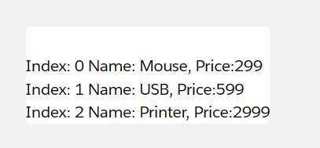

1. **~~if:true|false={expression}~~(Deprecated soon)**
2. **lwc:if|elseif={expression} and lwc:else**

Conditionally render DOM elements in a template. lwc:if, lwc:elseif, and lwc:else supersede the if:true and if:false directives.

Usage

* lwc:if and lwc:else

<template lwc:if={expression}></template>

<template lwc:else></template>

* lwc:if and lwc:elseif

<template lwc:if={expression}></template>

<template lwc:elseif={expression_elseif1}></template>

<template lwc:elseif={expression_elseif2}></template>

<template lwc:else></template>

**4.** **iterator:*iteratorName*={*array*}**

Applies special behavior to the first or last item in an array and renders a list. iterator:iteratorName={array} can be used with nested templates and HTML elements

**Component HTML File**

*<*template*>*

*<*lightning-card*>*

*<*template iterator:it={products}*>*

*<*div key={it.value.id}*>*

*<*p lwc:if={it.first}*>*

                    First Name:{it.value.Name} Price:{it.value.Price}

*</*p*>*

*<*p lwc:elseif={it.last}*>*

                    Last  Name:{it.value.Name} Price:{it.value.Price}

*</*p*>*

*<*p lwc:else*>*

                    Name:{it.value.Name} Price:{it.value.Price}

*</*p*>*

*</*div*>*

*</*template*>*

*</*lightning-card*>*

*</*template*>*

**Component JavaScript File**

import { LightningElement } from 'lwc';

export default class LwcDirective extends LightningElement {

    products=[

        {Id:12,Name:'Mouse',Price:299},

        {Id:14,Name:'USB',Price:599},

        {Id:15,Name:'Printer',Price:2999}

    ]

}

## Directives for HTML Elements

1. **for:each={array}**
2. **iterator:iteratorName={array}**
3. **key={uniqueId}**
4. **lwc:dom="manual"**